الاسم : عبدالرحمن طارق 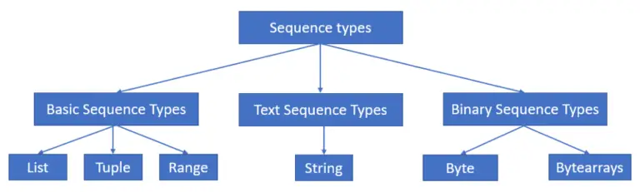

Sequence Data Types are used to store data in containers in the Python computer language. The different types of containers used to store the data are List, Tuple, and String. Lists are mutable and can hold data of any type, whereas Strings are immutable and can only store data of the str type. Tuples are immutable data types that can store any sort of value.

List

The sequential data-type class includes the list data type. The list is the sole mutable data type in the sequential category. It can store any data type's values or components. Many procedures in the list can be changed and performed, such as append, remove, insert, extend, reverse, sorted, etc. We still have many more built-in functions to manipulate lists.

## Strings

The string values are stored using string data types. We can't manipulate the elements in a string because it's immutable. Strings have a lot of built-in functions, and we can use them to do a lot of things. The following are some of the built-in string functions count, is upper, is lower, spilt, join, etc. In Python, single quotes, double quotes, and even triple quotes can be used to create strings. Generally, we use a triple quote to create a multiple-line string.

## Tuple

Tuples are a data type that belongs to the sequence data type category. They're similar to lists in Python, but they have the property of being immutable. We can't change the elements of a tuple, but we can execute a variety of actions on them such as count, index, type, etc. Tuples are created in Python by placing a sequence of values separated by a 'comma', with or without the use of parenthesis for data grouping. Tuples can have any number of elements and any type of data (like strings, integers, lists, etc.).

### Why Matrices are Crucial in Machine Learning & Data Science

The raison for emphasizing matrices in the scope of machine learning is multi-faceted. Here are some compelling reasons:

1. **Efficient Data Representation**: In machine learning, data often come in multi-dimensional arrays. Matrices serve as the most efficient way to represent and manipulate this data.
2. **Computational Efficiency**: Matrix operations, often optimized through techniques like vectorization, enable faster computations, which is critical when you’re dealing with large datasets.
3. **Optimization Techniques**: Techniques like gradient descent, which is pivotal in training machine learning models, inherently rely on matrix operations for optimization.
4. **Advanced Algorithms**: From neural networks to principal component analysis (PCA), many machine learning algorithms are built on the framework of matrix manipulations.
5. **Multivariate Statistical Methods**: Understanding covariance matrices, for example, is crucial when you’re dealing with multiple variables in statistical modeling.

Matrices play a **critical role** in **machine learning**. Let's explore their key applications:

1. **Data Representation**:

* **Feature vectors** (data points) are often represented as **matrices**.
* Each row corresponds to an instance, and each column represents a feature.

For example, in a dataset of house prices, each row could represent a house, and columns could be features like square footage, number of bedrooms, etc.

1. **Linear Transformations**:

Matrices enable **linear transformations**.

In dimensionality reduction techniques (e.g., **PCA**), matrices help find new coordinate systems.

They allow us to project data onto lower-dimensional subspaces.

1. **Linear Regression**:

In linear regression, we model the relationship between input features and output using a linear equation.

The coefficients of this equation are stored in a matrix.

1. **Matrix Factorization**:

Techniques like **SVD** (Singular Value Decomposition) and **NMF** (Non-negative Matrix Factorization) break down matrices into simpler components.

Useful for collaborative filtering, recommendation systems, and image compression.

1. **Convolutional Neural Networks (CNNs)**:

CNNs use **convolutional layers** that apply filters (kernels) to input data.

These filters are essentially **small matrices** that slide over the input, capturing local patterns.

CNNs excel in image recognition tasks.

1. **Recurrent Neural Networks (RNNs)**:

RNNs process sequences (e.g., time series, natural language).

Hidden states and weights are stored in matrices.

RNNs learn temporal dependencies.

1. **Optimization Algorithms**:

* Gradient-based optimization methods (e.g., **gradient descent**) involve matrix operations.
* Matrices store model parameters (weights and biases).

1. **Graphs and Networks**:

* Adjacency matrices represent relationships in graphs.
* Graph neural networks operate on these matrices.

1. **Kernel Methods**:

* **Kernel matrices** capture pairwise similarities between data points.

Used in support vector machines (SVMs) and kernel PCA.

1. **Eigenvalues and Eigenvectors**:

* Matrices help find eigenvalues and eigenvectors.
* These are crucial for dimensionality reduction and stability analysis.